**Telco Customer Churn Analysis**

**1. Project Overview**

The objective of this analysis is to investigate the factors influencing customer churn in a California-based telecommunications company. By identifying patterns and correlations within customer data, the goal is to deliver strategic insights that support more effective customer retention strategies in an increasingly competitive market.

**2. About the Dataset**

This dataset represents customer information from a fictional telecom company in the United States. It includes demographic attributes, service subscriptions, and churn status, enabling the identification of key churn drivers—i.e., why customers cancel their services.

**Key Attributes:**

* **Customer Demographics:** Gender, city, state, ZIP code, and geographic coordinates (latitude and longitude).
* **Subscription Information:** Contract type (month-to-month, one-year, two-year), payment method (e.g., electronic check, mailed check, credit card), and monthly charges.
* **Churn Data:** Churn status (Yes/No), churn score, reasons for churn, and customer lifetime value (CLTV).
* **Churn Reasons:** Detailed reasons include competitor advantages, dissatisfaction with service, or relocation.

**3. Data Preparation**

Data cleaning and transformation were conducted using Power Query Editor, with the following steps:

* Verified the number of rows and columns imported against the source file.
* Updated the data types for CustomerID and count-related columns.
* Replaced null values in the **Churn Reason** column with "Unknown".

**4. Data Modeling**

As the dataset contains only a single table, no data modeling or table relationships were required.

**5. Data Visualization**

The dashboard contains:

* **Overview Page** – Summary of the data and KPIs.
* **Demographics Page** - Analyzes the customers' demographics based on gender and age.
* **Subscription Page** - Analyze the services that customers subscribed to.
* **Contract & Payment Page** – Analyze the contract types, and payment methods.

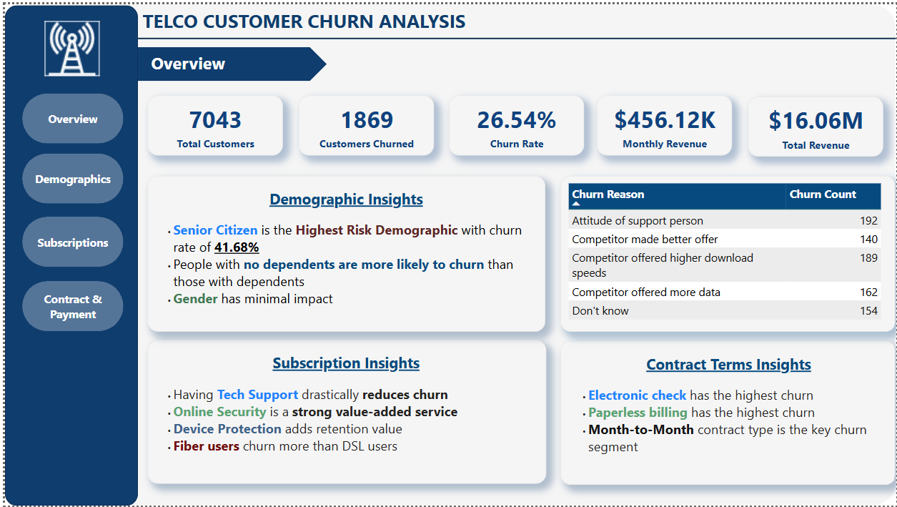

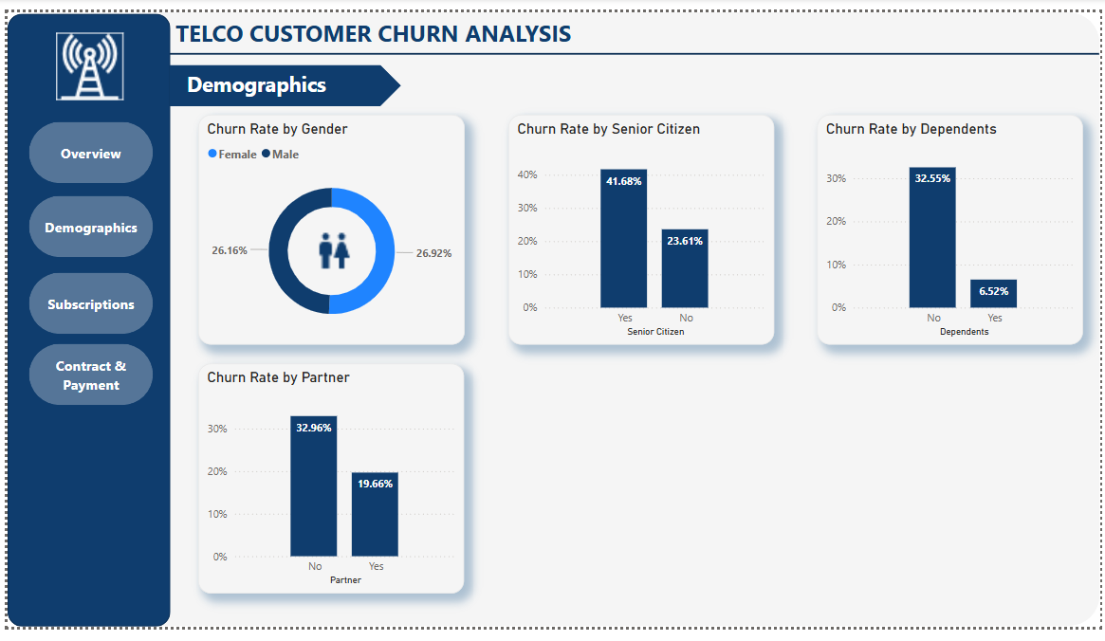

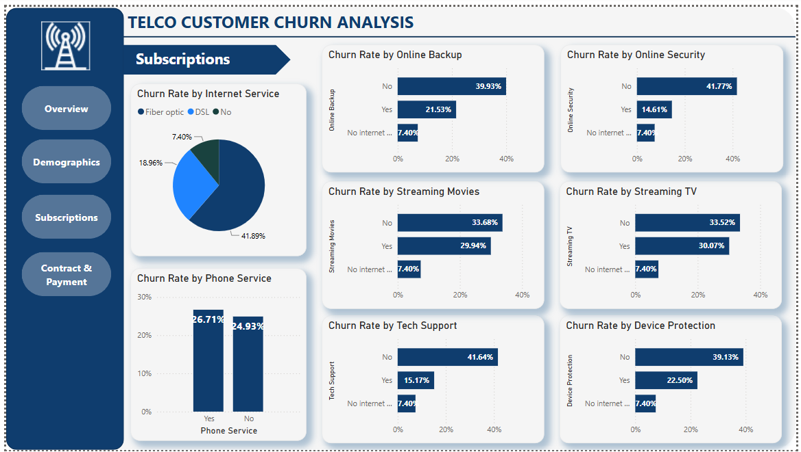

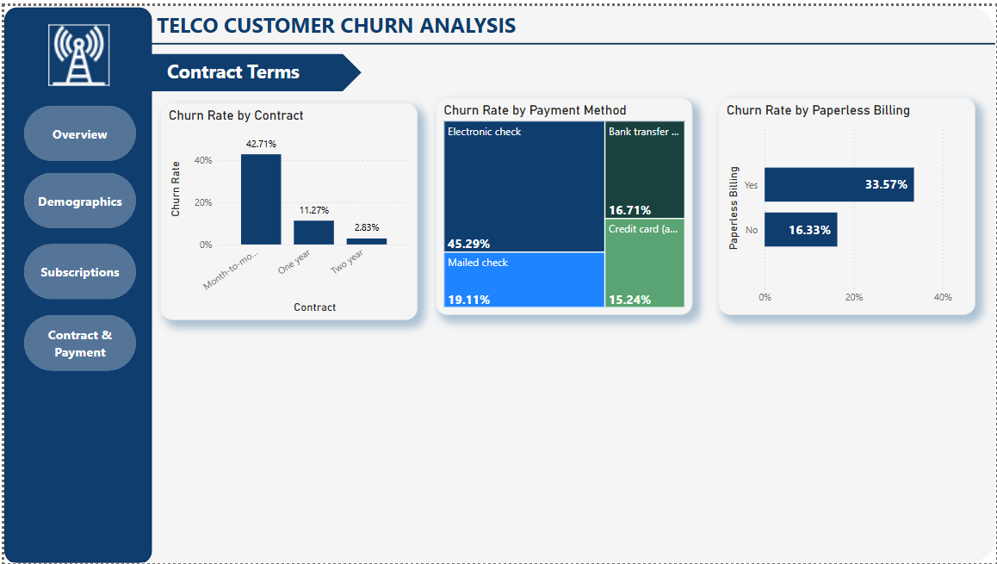

**6. Key Insights from the Dashboard**

**Overview**

* **Churn Rate:** 26.54% (1,869 churned out of 7,043 customers).
* **Revenue Impact:** $456.12K monthly revenue loss; $16.06M total revenue at risk.

**Top Churn Reasons**

* Poor service experiences:
  + “Attitude of support person” – 192 cases
  + “Attitude of service provider” – 135 cases
* Competitive alternatives:
  + “Competitor offered higher speeds” – 189 cases
  + “Better data plans” and “More attractive offers” – ~130–160 cases

**Demographic Patterns**

| **Segment** | **Churn Rate** | **Insight** |
| --- | --- | --- |
| Senior Citizens | 41.68% | Highest risk demographic |
| No Dependents | 32.55% | More likely to churn than those with dependents |
| No Partner | 32.96% | Single users are more likely to leave |
| Gender (M/F) | ~26% | Gender has minimal impact |

🔍 **Conclusion:** Focus retention efforts on senior citizens and single customers without dependents.

**Subscription & Service Insights**

| **Service** | **Churn (No)** | **Churn (Yes)** | **Insight** |
| --- | --- | --- | --- |
| Tech Support | 41.64% | 15.17% | Having support drastically reduces churn |
| Online Security | 41.77% | 14.61% | A strong value-added service |
| Device Protection | 39.13% | 22.50% | Adds retention value |
| Internet (Fiber) | 41.89% | — | Fiber users churn more than DSL users (18.96%) |

✅ **Conclusion:** Bundled services improve retention significantly.

**Contract & Payment Preferences**

| **Factor** | **High-Risk Category** | **Churn Rate** | **Insight** |
| --- | --- | --- | --- |
| Contract Type | Month-to-Month | 42.71% | Key churn segment |
| Billing Method | Paperless Billing (Yes) | 33.57% | Higher churn—possibly more tech-savvy leavers |
| Payment Method | Electronic Check | 45.29% | Highest churn—review UX or security concerns |

**7. Recommendations Based on Insights**

1. **Targeted Retention Campaigns**
   * Focus on senior citizens, single customers, and those with short-term contracts.
   * Offer loyalty incentives to switch from month-to-month to longer-term contracts.
2. **Bundle Services Strategically**
   * Promote packages combining tech support and online security.
   * Market value-added services especially to high-risk segments (fiber users, streamers).
3. **Enhance Support Quality**
   * Address dissatisfaction stemming from support experiences.
   * Invest in soft-skills training and implement customer feedback loops.
4. **Encourage Contract Upgrades**
   * Introduce early renewal discounts or added benefits for longer commitments.
5. **Optimize Billing & Payment Experience**
   * Investigate churn patterns among electronic check users.
   * Improve online billing transparency and trust signals.